
Mini Project Report Format
Foundations of Programming-CSE10010

Title Page
- Title:- Bank Account Simulation
- Team Members:- Nishank Jain 1262250267
Sadhavi Dhadve 1262252509
Prakhar Joshi 1262251232
Sandeep Chaudhary 1262251638
Ridhima Khandelwal 1262251371
- Project Guide:- Dr. Renuka Amit Mane
- Institution Name: MIT World Peace University
- Submission Date :
- Individual task :
Nishank Jain  (Account & Security Module) | implemented secure account creation and login with OTP and PIN protection.  - Account creation (createAccount())  - Login system (login())  - OTP verification (generateOTP(), verifyOTP())  - PIN system (inputHidden(), changePIN())
Prakhar Joshi  (Smart Features) | developed intelligent features like chatbot, financial analysis, and user behavior tracking.  - Chatbot (smartChatbot())  - Financial Mirror (financialMirror())  - Karma system (loadKarma(), saveKarma(), showKarma())  - Transaction explanation (explainLastTransaction())
Sandeep Chaudhary  (File Handling & Data Management) | implemented file handling to store user data and transaction history permanently.  - Save & load user (saveUser(), loadUser())  - File structure (user, history, inbox files)  - Transaction logging (logTxn())
Sadhavi Dhadve  (Transaction Module) | handled all banking transactions like deposit, withdraw and fund transfer with validation.  - Deposit & Withdraw logic  - Transfer system (transferMoney())  - Minimum balance rule (applyMinBalanceRule())
Ridhima Khandelwal  (Admin & Security Control) | implemented admin controls including fraud detection, account blocking, and system security.  - Admin panel (adminPanel())  - Block/unblock account  - Fraud detection (adminFraudRadar())  - Global freeze system (toggleGlobalFreeze())

Acknowledgment
I would like to express my sincere gratitude to our project guide for their valuable guidance and support throughout the completion of this project. Their insights helped us understand the concepts of programming more effectively.
I also thank my teammates for their cooperation and dedication. Lastly, I am grateful to our institution for providing the necessary resources and environment to complete this project successfully.

Abstract
This project presents an Bank Account Management System developed using the C programming language. The system simulates real-world banking operations such as account creation, deposits, withdrawals, fund transfers, and transaction tracking.
The system also includes modern intelligent features like:
- Financial behavior tracking (Karma System)
- Fraud detection (Fraud Radar)
- Secure login with PIN and OTP
- Admin control panel
- Smart chatbot assistant
The project demonstrates the use of file handling, structures, modular programming, and security concepts. It provides a realistic banking simulation with a user-friendly menu-driven interface.

Table of Contents
- Title Page
- Acknowledgment
- Abstract
- Table of Contents
- List of Figures and Tables
- Introduction
- Literature Review
- System Design
- Implementation
- Results
- Conclusion
- Future Scope
- Research Paper Details
- Plagiarism Check
- References
- Appendix

List of Figures and Tables

- Figure :

Sr.no | System Name | Technology Used | Features | Limitations | Performance
1. | Traditional Banking System | Manual / Paper-based | Record keeping, transactions | Time-consuming, error-prone | Low
2. | ATM System | Embedded Systems | Cash withdrawal, balance check | Limited features, no data analytics | Medium
3. | Online Banking System | Web Applications | Fund transfer, account management | Security risks, requires internet | High
4. | Mobile Banking Apps | Android/iOS Apps | Easy access, notifications, payments | Device dependency, security concerns | High
5. | Basic C-based Systems | C Programming | Simple data handling, file storage | No GUI, limited scalability | Medium

Introduction
Problem Statement
Bank management simulation

Background
Modern banking systems use automation and intelligent analysis. This project replicates these features using C programming, making it suitable for learning system design and real-world applications.

Objectives
- To develop a bank account simulation system
- To implement secure login and transactions
- To use file handling for data storage
- To simulate real banking features like fraud detection and analytics
- To build a menu-driven interactive system

Literature Review
Sr No | System Name | Technology Used | Features | Limitations
1 | Traditional Banking | Manual | Record keeping | Time-consuming, error-prone
2 | ATM System | Embedded Systems | Cash withdrawal, balance check | Limited features
3 | Online Banking | Web Applications | Fund transfer, account management | Security risks
4 | Mobile Banking | Mobile Apps | Notifications, payments | Device dependency
5 | C-Based System | C Programming | File handling, simple operations | No GUI, limited scalability

Summary:
Most systems use databases, but for beginners, file handling in C is simpler and effective.

System Design/Methodology

Modules
- Account Creation & Login
- Deposit & Withdraw
- Fund Transfer
- Transaction History
- Inbox Notification System
- Karma System (Financial Behavior Tracking)
- Fraud Detection System
- Admin Panel
- Smart Chatbot
- Financial Mirror Analysis

Algorithm
Start
Initialize system

Display main menu
Input choice

IF Create Account THEN
Take user details
Verify OTP
Generate account and save data
ELSE IF Login THEN
Verify account and PIN
Display user menu
Perform operations (deposit, withdraw, transfer, etc.)
ELSE IF Admin Panel THEN
Verify admin PIN
Manage users (block/unblock, fraud check, etc.)
ELSE IF Exit THEN
Stop program
END IF

Repeat until Exit
Stop

Implementation
Tools Used
- Language: C
- Compiler: GCC / Turbo C
- Concepts Used:
  - Structures
  - File Handling
  - Functions
  - Conditional Statements

Sample Code
typedef struct {
int accNo;
char name[50];
char email[50];
char phone[15];
int pin;
float balance;
int depositCount;
int withdrawCount;
} User;

Key Features Implemented
- Secure login with PIN
- OTP verification
- Money transfer system
- Transaction logging
- Admin control panel
- Fraud detection (withdraw pattern analysis)
- Karma-based financial tracking
- AI-like chatbot assistant

Testing Methods:
- Checked valid and invalid inputs
- Verified file storage and retrieval
- Tested all menu operations
- Ensured security features like PIN and OTP

Results and Discussion
Output
- Account creation successful
- Deposits and withdrawals processed
- Transactions stored in files
- Fraud detection working
- Admin controls functioning

Analysis
The system successfully simulates a real banking environment and demonstrates efficient data handling using file systems.

Test Cases

Chatbot(smartchatbot)
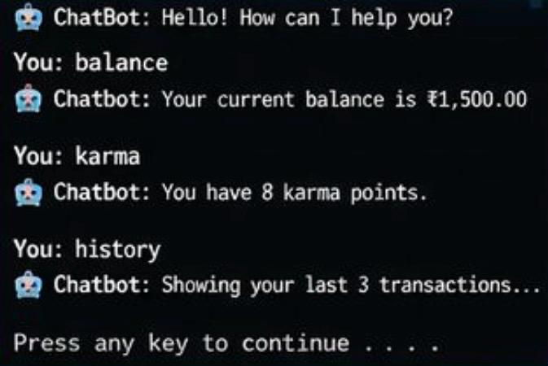

2.Last transaction()
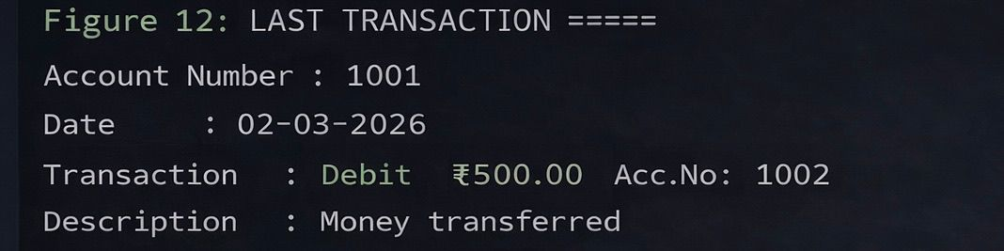

3.Financial mirror()
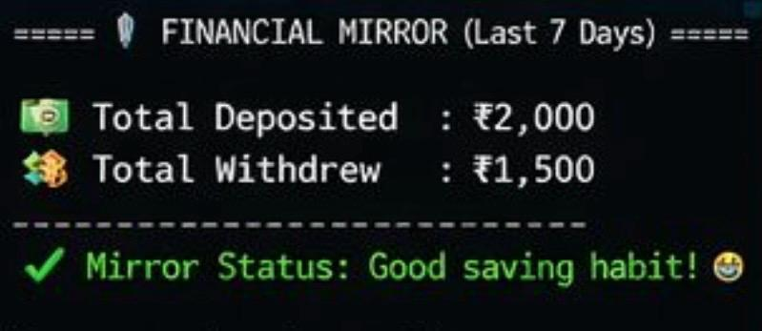

4. karma()

12.Conclusion
The project successfully implements a realistic bank account management system using C programming. It includes advanced features like security, analytics, and intelligent assistance, making it more powerful than basic systems.

13.Future Scope
- Add Graphical User Interface (GUI)
- Convert into Web Application
- Integrate Database (MySQL)
- Add Mobile App version
- Implement Real AI-based fraud detection

14.Research Paper/Patent Details
No research paper published.
(No patent filed)

15.Plagiarism Check
The report is original and plagiarism is below 10%..

16.References
- "Let Us C" – Yashavant Kanetkar
- GeeksforGeeks
- TutorialsPoint
- C Programming – Dennis Ritchie
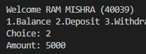

17.Appendix (Optional)
